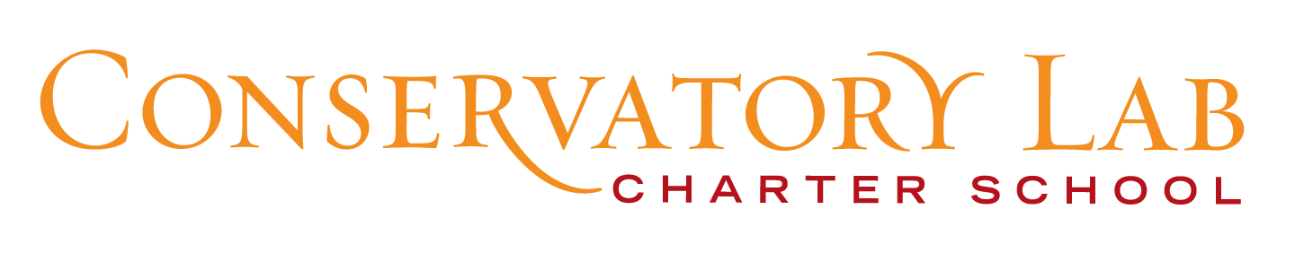
April 19, 2016
To: Executive Office for Administration and Finance
State House Room 373
Boston, MA, 02133
Tel: 617.727.2040 Fax: 617.727.2779
From: Cecilia Soriano, Director of Marketing,Communications & External Relations
csoriano@conservatorylab.org
617-254-8904 X 105
Send via email to:
(melissa.andrade@state.ma.us)
_____________________________________________________________________________________Notice of Conservatory Lab Charter School
Board Meeting
April 25, 2016
4:00 p.m. – 5:30 p.m.
Conservatory Lab Charter School
2120 Dorchester Ave., Dorchester, MA. 02124

Agenda
- Approval of Minutes of 4/4/16
- Public Comment
- Overview of the Work Ahead
- Update on Dorchester Collegiate Academy Building

Board Retreat
- Focus: How can the board respond proactively and effectively to change as the organization grows larger and more complex and takes on new leadership. Larry Langford, an experienced facilitator in schools and non-profits, will facilitate the retreat.

April 15, 2016
7:00p.m.
University Club
426 Stuart St.
Boston, MA 02120

